Instruction 3

The Purpose of SDG 4

A brief explanation about the purpose of the SDG goal:
State the official title: Quality Education
Summarize the goal’s aim by 2030: The purpose is to ensure inclusive and equitable quality education and promote lifelong learning opportunities for all (United Nations Department of Economic and Social Affairs, n.d.).
Mention two key indicators:
Target 4.1: By 2030, ensure that all girls and boys complete free, equitable and quality primary and secondary education leading to relevant and effective learning outcomes.
Target 4.2: By 2030, ensure that all girls and boys have access to quality early childhood development, care and pre-primary education so that they are ready for primary education
Keep it focused: SDG 4 puts great emphasis on the immense significance that quality education brings to the single person. Education is regarded as a key manner for poverty elimination, gender equality and sustainable development. Moreover, quality education is a core enabler in empowering individuals to participate in society completely (United Nations Educational, Scientific and Cultural Organization (UNESCO), 2026).
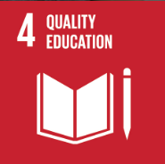
Sourced from: THE 17 GOALS | Sustainable Development

Adverse Causes and Consequences in China
Nowadays, China still faces continuous issues in SDG 4, despite the immense advancement in education. There are some primary consequences and corresponding factors about the progress.

what adverse impacts, why and how:

What: The imbalance in the allocation of regional education.
Why: Economically developed areas, such as major cities and special economic zones, due to their industrial agglomeration effects and higher fiscal revenues, can receive more education funding (Huang, 2024).
How: The well-developed regions enjoy sufficient funding, advanced teaching facilities, and knowledgeable teachers. However, the economically developing areas, like some remote villages, lack all these resources. As a result, these poor regions are unlikely to provide various and high-quality education for students.

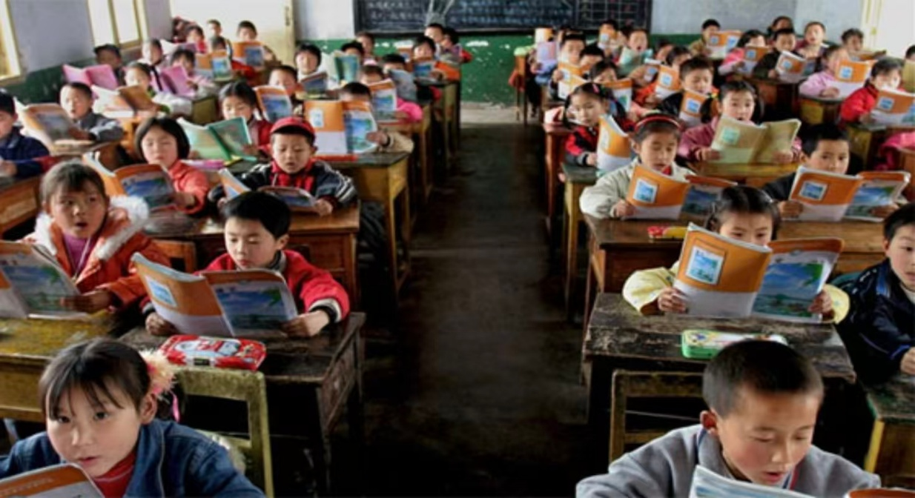
Sourced from: Leadership Society of Arizona: Issues of China education system

What: Disadvantaged groups have unequal chances for education.
Why: This probably stems from systemic factors including family poverty, geographic isolation, and lack of parental care.
How: Many low-income students cannot afford tuition fees. At the same time, they are more possible to drop out of school, due to the inconvenient access to school, high cost of family education expenditure, and lack of parental companionship. The retention rate of nine-year compulsory education was 95.9%, but there are still 4.1% of students unable to graduate due to the above reasons (Ministry of Education of the People’s Republic of China, 2025). In Yunnan province, children walk hours on unsafe paths such as bridge to go to school.
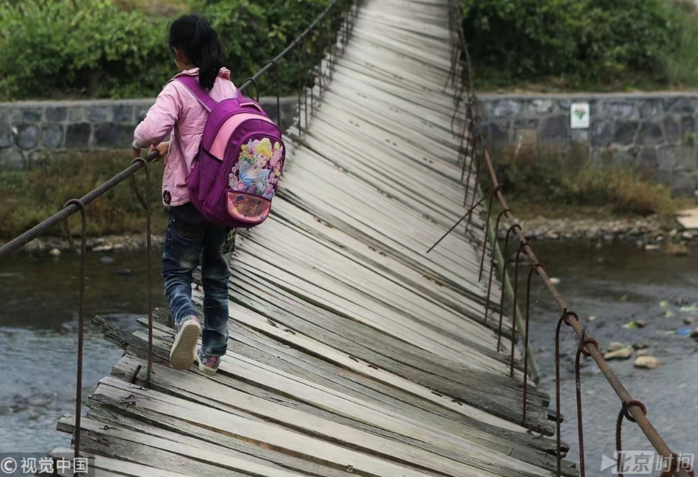

Sourced from: BTIME Report: Challenges in Yunnan's rural education

What: The popularization of lifelong learning is inadequate.
Why: Limited public funding for adult education and low penetration rate of digital learning platforms.
How: Rural adults often have no access to literacy classes or vocational training. For instance, many seniors cannot use smartphones to get learning apps, which restricts their potential abilities in digital lifelong learning.
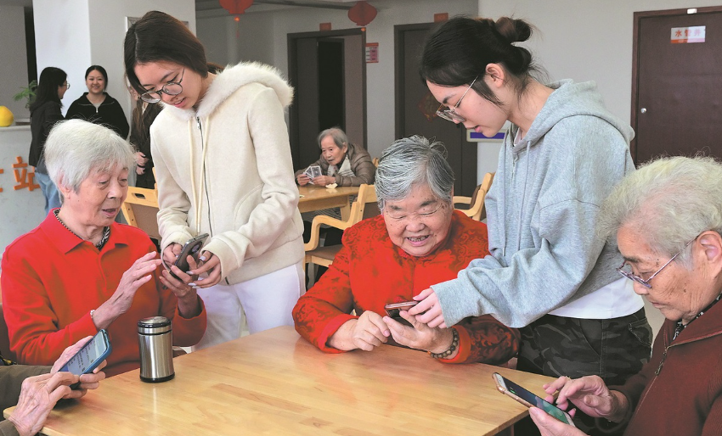
Sourced from: China Daily: More nuanced approach to aging needed

What: Digital divides exacerbate educational inequality.
Why: Uneven access to internet infrastructure and digital devices create barriers to learning.
How: Online education has become a crucial trend; nevertheless, it also widens some new gaps. Urban students equipped with stable internet, personal devices, and comprehensive digital resources. However, rural students even lack even basic resources. During the pandemic, some had to walk kilometers to find a signal. This divide not only undermines the education equality but also slows down the progress toward SDG 4.
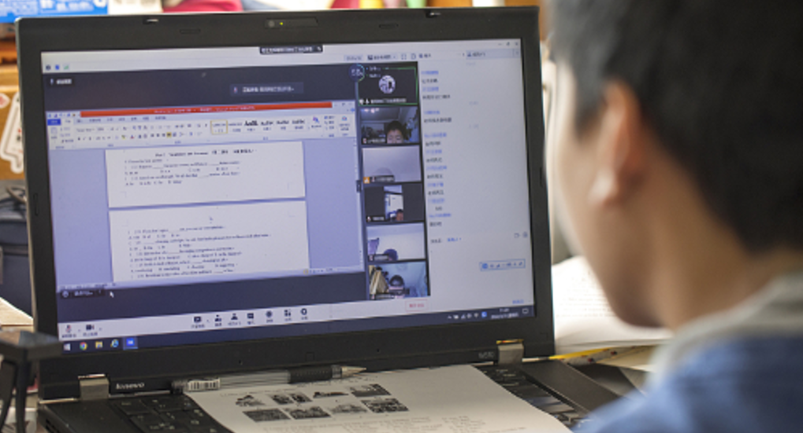
Sourced from: CGTN: Shanghai to resume in-person classes for most high school students from June 6

Who (shareholders):

Directly Affected Groups:
Rural students, left-behind children, children of migrant workers: Face fewer resources, less qualified teachers, and fewer educational opportunities.
Students in underdeveloped central, western regions in China, students from low-income families: Suffer from poor school conditions, limited access to quality education
Students with disabilities: Lack accessible school facilities, tailored teaching support.
Rural adults and the elderly: Having no access to learning platforms prevents them from the goal of lifelong learning.

Indirectly Affected Groups:
Teachers in under-resourced regions: Work with limited support and face heavy teaching burdens.
Government education departments: They are needed to invest more money to solve the gaps between regions.
Technology industries needing skilled workers: Talent shortage which will slow down the innovation process.
Charitable organizations: Add more assistance to help students which are easy to create pressure to this organization.

Personal Solutions
With the aims of addressing these challenges and advance SDG 4 in China, as a university student, I propose manifold feasible solutions.
First, everyone should actively participate in tutoring programs for rural students, principally concentrating on the improvements of their digital literacy skills. Leading weekly online classes to impart basic skills will be conducive to narrow the existing education gap.
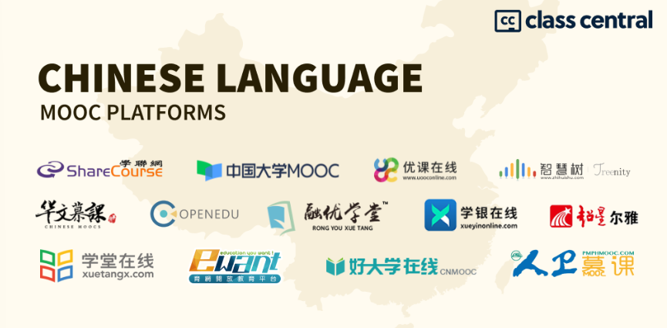
Sourced from: Massive Class Central: List of Chinese Online Course Platforms in 2026

Second, revising curricula and assessment systems is integral. Schools can include various practical tasks in regular evaluation, involving collaborative projects, internet use assessment, and basic critical tests.
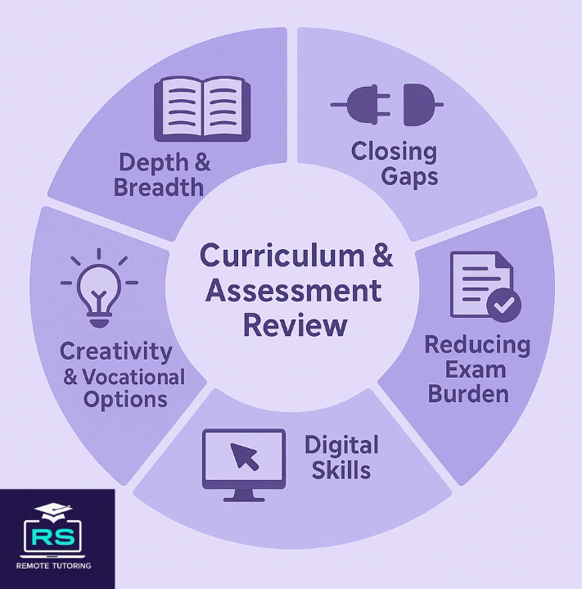
Sourced from: New GCSE Curriculum Review 2026: Preparation Guide

Third, advocate for lifelong learning and vocational education. More information about professional opportunities and the significance of perpetual learning are needed to be known by most people. Then, more lectures held by professionals are required to help students explore diverse career paths.
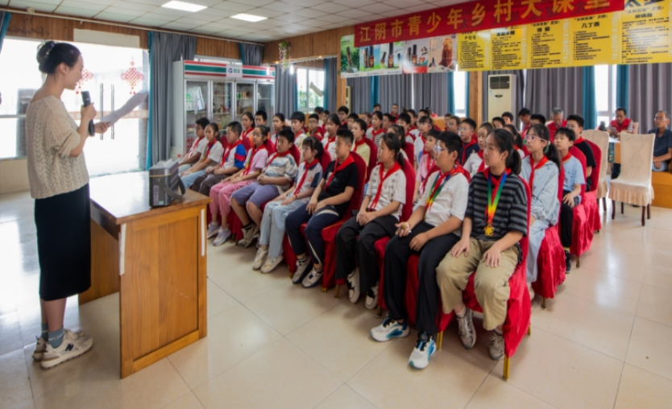
Sourced from: Wuxi Agricultural and Rural Bureau: Jiangyin youth rural classroom report

Instruction 4

2.What a ‘Carbon Footprint’ is
As Britannica Editors (2026) note that carbon dioxide is the most significant greenhouse gases linked to global warming. It refers to the total amount of greenhouse gases-primarily carbon dioxide, emitted by an individual, product, or activity. Carbon dioxide is commonly measured in CO₂e (carbon dioxide equivalent) indirectly and directly (Carbon expert,2026). It helps people to measure their climate impact and target reductions. We produce direct carbon dioxide by diving cars, using electricity, cooking and warming, while create indirect carbon dioxide through using paper, stationary, consuming food. There are numerous manners contributing to carbon dioxide. So, calculating carbon dioxide and reducing it is an integral part to fulfill our goal.

3.a The purpose of the ‘Action’

My action:
“Reduce, reuse, repair, recycle”
Electronics, clothes, plastics and other items we buy cause carbon emissions at each point in production, from the extraction of raw materials to manufacturing and transporting goods to market. To protect the climate, buy fewer things, shop second-hand, and repair what you can. Plastics alone generated 1.8 billion metric tons of greenhouse gas emissions in 2019 – 3.4 per cent of the global total. Less than 10 per cent is recycled, and once plastic is discarded, it can linger for hundreds of years. Buying fewer new clothes – and other consumer goods – can also reduce your carbon footprint. Every kilogram of textiles produced generates about 17 kilograms of CO2e. (United Nations, n.d.)

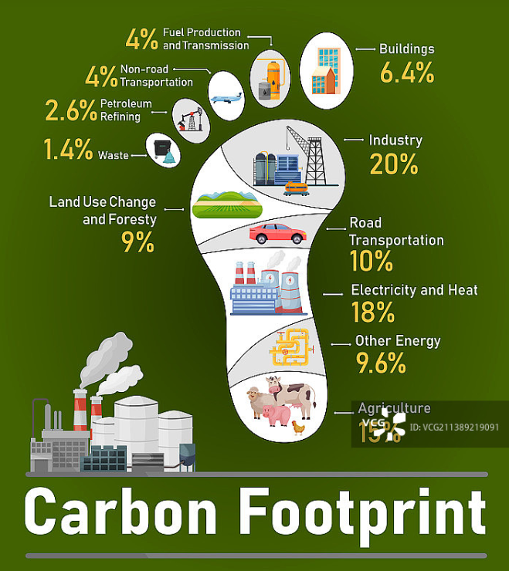

Sourced from: Visual China Group: Carbon foorprint distribution

Why (the mechanism):
The 4R action reduces greenhouse gas emissions by targeting every stage in the lifecycle of products. Every product generates emissions in the process of lifecycle, involving raw material extraction, manufacturing, transporting, and disposal. By diminishing unnecessary consumption, we cut down production, avoiding carbon emission. Recycling and reusing items can lengthen the lifespan, eliminating the unnecessary need for new production. Recycle means repurposing resources intended for one task to a different task (Scells et al., 2022). Recycling diverts materials back into production, which uses far less energy. In conclusion, all these actions break the normal PLC (product life cycle), realizing the measurable reductions in both emissions.

How (Example):
In my daily life, the chosen action truly works as a following way. First, bring a reusable water bottle to reduce the frequency of use for disposable items. Then, use second-hand textbook and stationery as often as possible. Moreover, fix the torn clothes and broken books instead of purchasing a new one to substitute. Furthermore, categorize paper, plastic, and metal waste for better recycling. An instance of this lifestyle not only contributes a more affordable and sustainable lifestyle for individuals, but also play an essential role in reducing carbon emission.

Co-benefits:
(1) Financial savings: Extending the lifecycle of items and avoiding unnecessary purchases can lower the expenditure on goods, subsequently cutting down cost for living.
(2) Biodiversity and ecosystem protection: The decreasing demand for raw materials lessen destruction from mining, logging and manufacturing.
(3) Public health improvements: Cutting down the frequence of using plastics lowers the exposure of harmful chemicals, while less waste indicates the less pollutants brought by waste.
(4) Circular economy promotion: This action supports a shift from the linear “take-make-waste” model to a circular economy (United Nations Development Programme, n.d.). The circular economy decreases the waste it improves efficiency of using resources as well.
(5) Education and social impacts: Practicing these habits can help foster sustainable awareness towards consumption, which aligns with SDG 4 and stimulates others to adopt a low-carbon lifestyle.

3.b Calculate individual carbon footprint

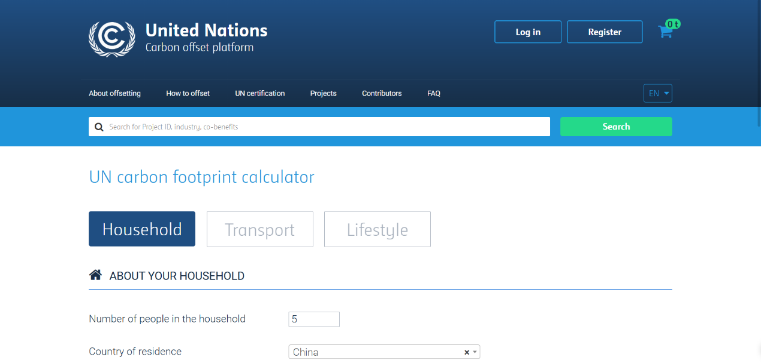
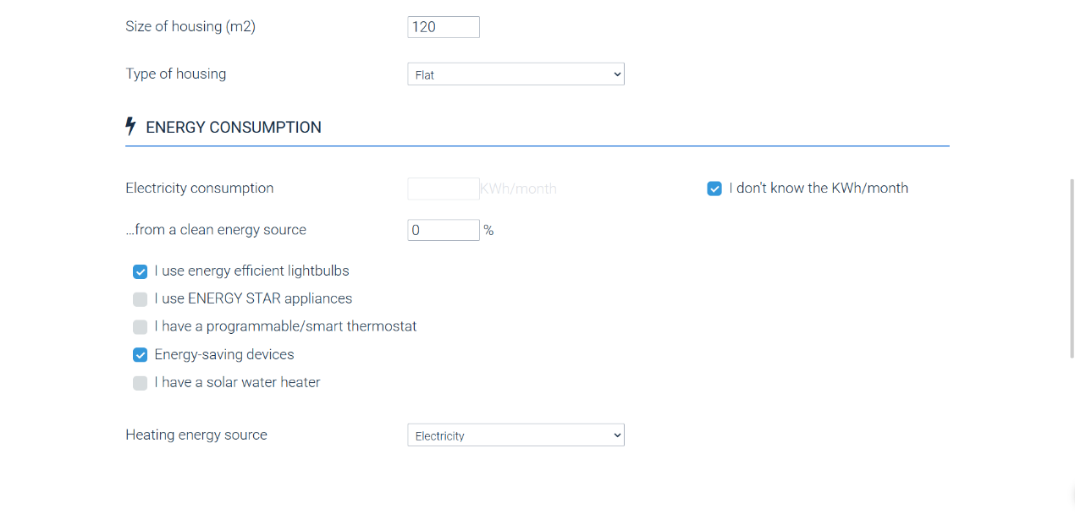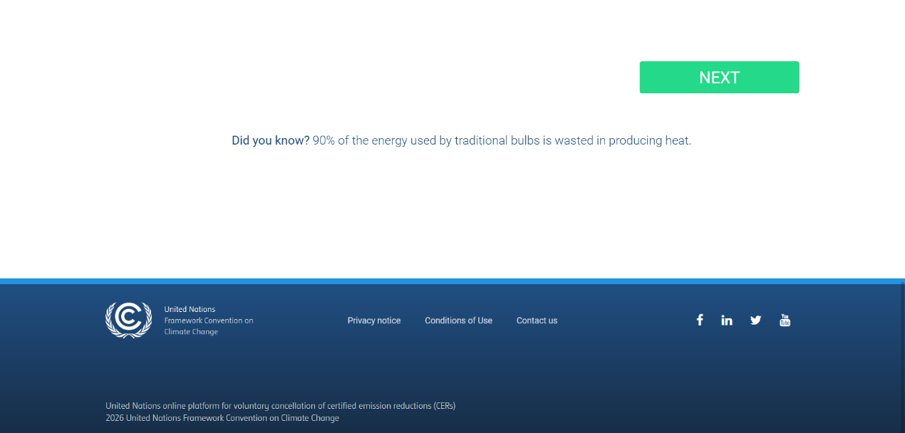

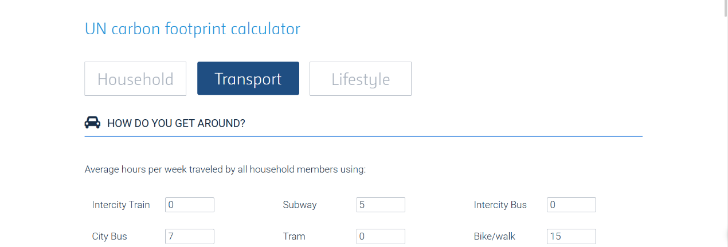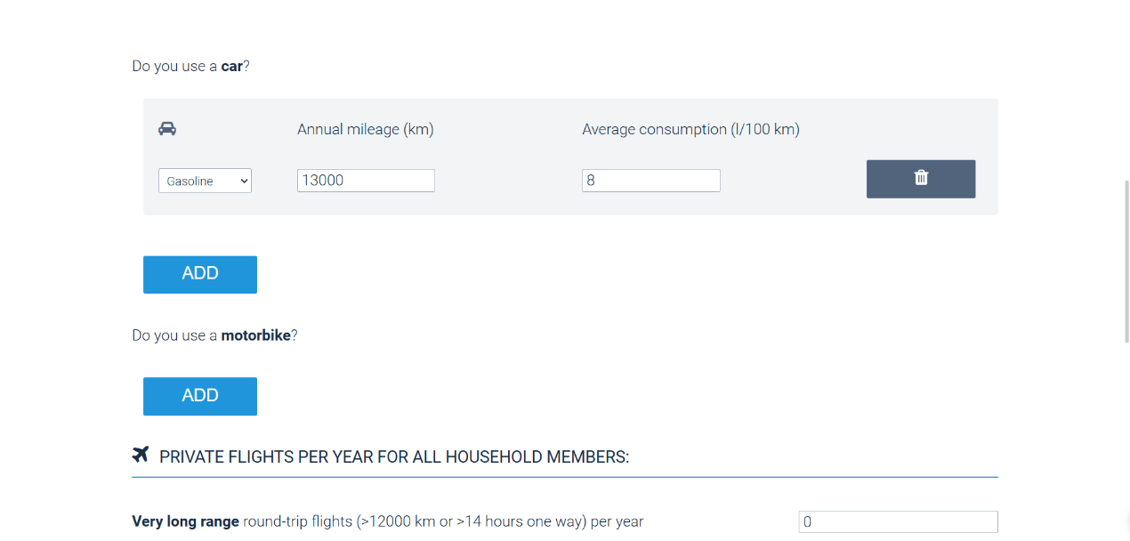
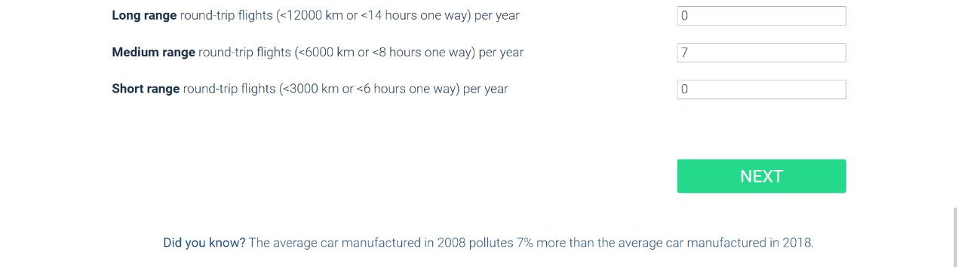

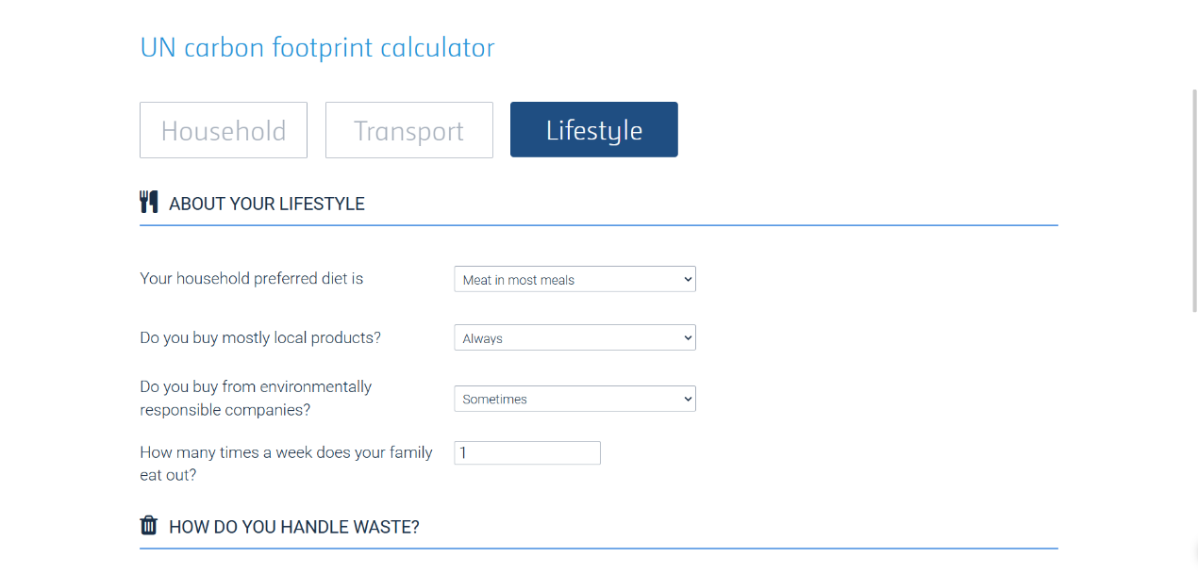
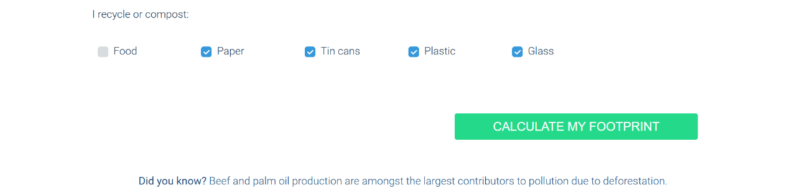

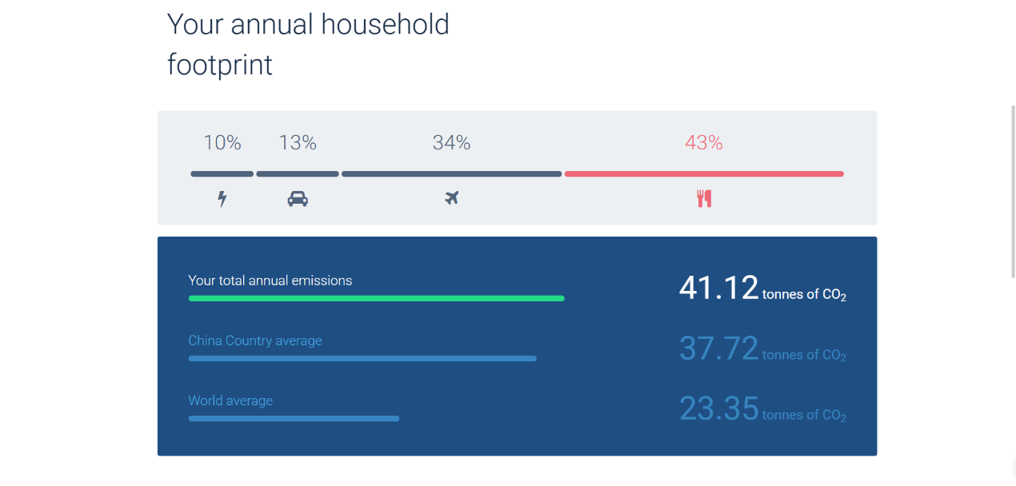
Sourced from: United Nations online platform for voluntary cancellation of certified emission reductions (CERs)

Comment:
According to the calculation, annual carbon dioxide of my family is 41.12 tons of CO2. This amounts to approximately 8.22 tons per person a year, which is more than the 2t target for a sustainable lifestyle. Moreover, it exceeds both Chian country average and world average in the figure.
From a view of components, food and transportation, which accounts for 43% and 34% respectively, are the largest contributors. The smallest one is energy use, with a proportion of 10%. Therefore, this consequence reminds us to change the incorrect lifestyle, especially shifting to a more plant-based diet pattern, cutting down travel by air and car, and optimizing energy use.

After taking action:
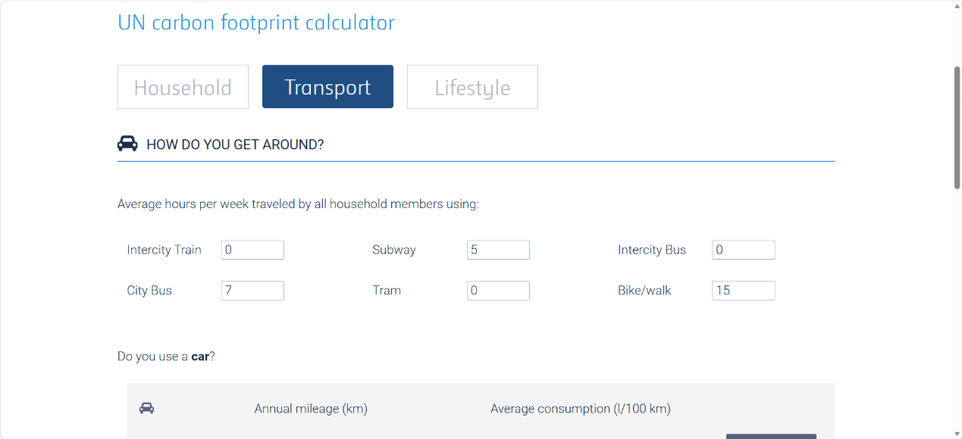

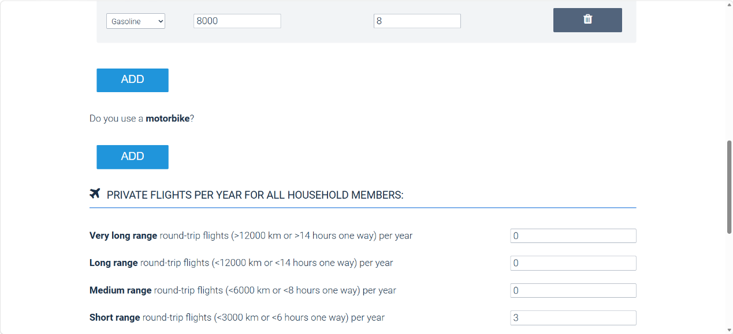
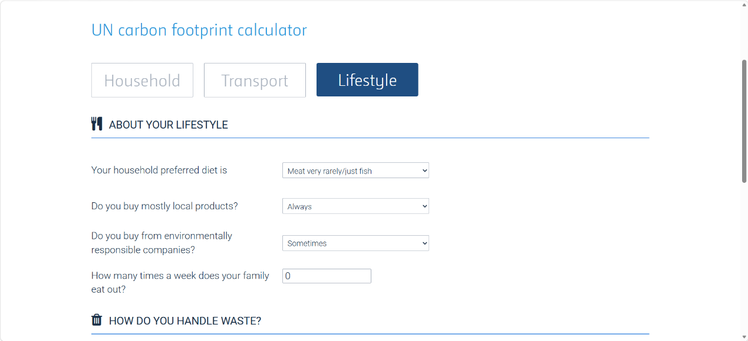
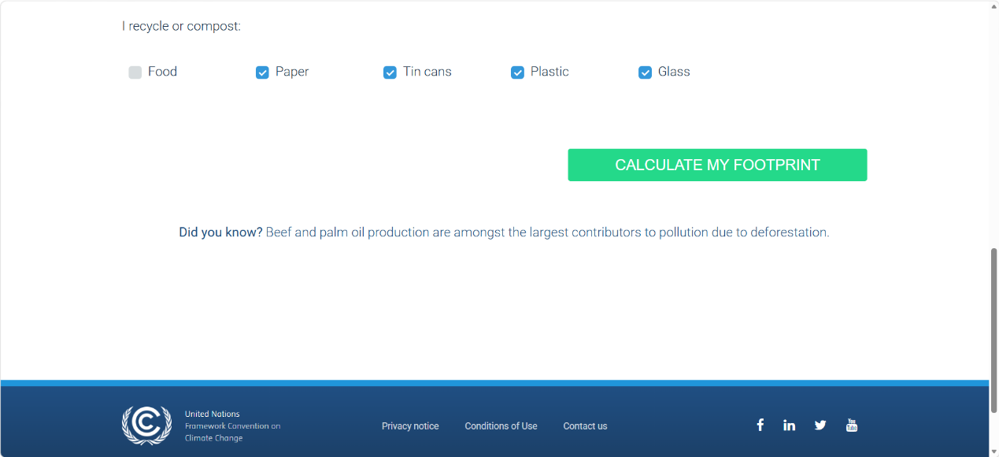
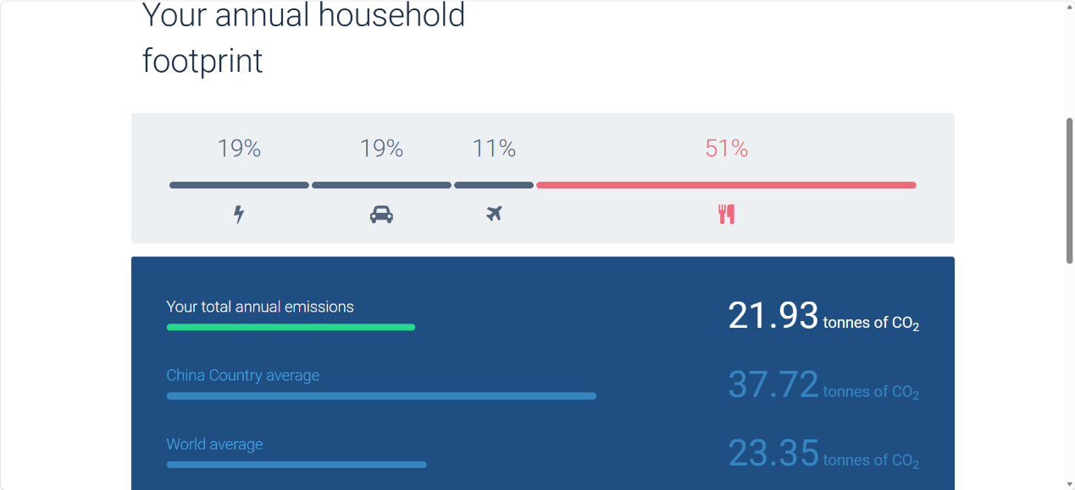

Argue:
The change substantially decreases the family carbon footprint, verifying the credibility of these actions. By cutting down annual car use by 5000 km and reducing flight trips to only 3 times, my transportation-based emissions fall by nearly 50%, due to the reduction on fossil fuel use. Switching to a diet that consuming more vegetables than meat and eliminating weekly eat-out are also beneficial to reduce emissions, because the decrease on livestock farming. So, my annual carbon emissions drop from 41.12 tons to only 21.93, below both China’s and the global average. Moreover, the mentioned actions are highly replicable for everyone: It is simple and convenient. Their combined role will greatly help realize the climate action goal.

Reference List
Britannica Editors. (2026, 5 5). carbon dioxide. Retrieved from Britannica: https://www.britannica.com/science/carbon-dioxide
Huang, X. (2024). Research on the Formation and Evolution Mechanism of the Urban-Rural Education Gap in China. Academic Journal of Humanities & Social Sciences, 7(7), 152-157. https://doi.org/10.25236/AJHSS.2024.070723
Ministry of Education of the People’s Republic of China. (2025). 2024 national education development statistical bulletin. Ministry of Education of the People’s Republic of China.
Scells, H., Zhuang, S., & Zuccon, G. (2022). Reduce, Reuse, Recycle: Green Information Retrieval Research. Proceedings of the 45th ACM SIGIR Conference on Research and Development in Information Retrieval. Madrid: Association for Computing Machinery. https://doi.org/10.1145/3477495.3531738
United Nations. (n.d.). Actions for a healthy planet. Retrieved from United Nations: https://un.org/en/actnow/ten-actions
United Nations Department of Economic and Social Affairs. (n.d.). Goal 4: Ensure inclusive and equitable quality education and promote lifelong learning opportunities for all. Retrieved from United Nations Sustainable Development Goals: https://sdgs.un.org/goals/goal4
United Nations Development Programme. (n.d.). A circular economy aligns environmental protection with long-term economic and social well-being. Retrieved from UNDP (United Nations Development Programme): https://www.undp.org/chemicals-waste/our-work/circular-economy
United Nations Educational, Scientific and Cultural Organization (UNESCO). (2026). Higher education global trends report: Towards inclusive, equitable and quality higher education in an internationally mobile landscape. UNESCO.

